**Table of Content**

|  |  |
| --- | --- |
| **Title** | **Page** |
| **Task 1: Organisation Background** |  |
| **Task 2: Develop Business Rules** |  |
| **Task 3: Develop Entity-Relationship Diagram (ERD)** |  |
| **Task 4: Develop Database Design Language (DBDL)** |  |
| **Task 5: Create Database Tables in Oracle** |  |
| **Task 6: Create Records** |  |
| **Task 7: Create Queries** |  |
| **Task 8: Personal Reflection** |  |
|  |  |

**Task 1: Organisation Background**

In the era that most of the people are more rely on convenient, online ticketing is being used world-wide spread. One of the popular cinemas in Malaysia, which is MBO Cinema also adopting online ticketing system to take advantage in the Media and Entertainment industry. Hence, it could also help them to keep pace with their competitor which is TGV Cinema and GSC Cinema. MBO Cinema having more than thousand screens in Malaysia and numerous of defunct cinema as they found certain cinemas couldn’t reach their ideal outcome. They are getting more trendy among audiences and had merged rapidly in the industry of cinema in Malaysia, as the rapid merging of their company, they are currently top 3 cinema in Malaysia.

**Name:** MBO Cinema

**Company Size:**

* Having 1179 screens across Malaysia and numerous of defunct cinema.
* Having 27 outlets in Malaysia.

**Background :**

* First founded in 2003.
* Latest MBO Cinema opened in Selangor at Atria Shopping Gallery which is located in Damansara Jaya.
* Have movie hall that is built for children and family called KECIL, features with beanie seats, sofa seats and in-hall playground.
* Offers 2D Film in all of their outlets and 3D Film are available in Citta Mall, Subang Parade and more.

**Industry:** Media and Entertainment

**Hierarchical Organization Chart**

**System Structure Chart**

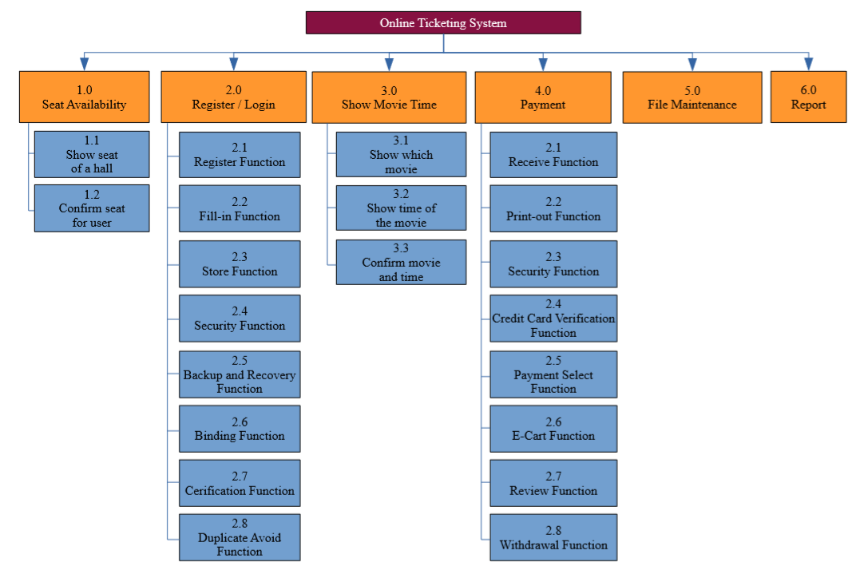

**Task 2: Develop Business Rules**

**Business Rule**

1) One customer may have many ticket details, each ticket details only can collect by one customer.

2) One ticket details may apply for any different seat, each seat only have one ticket detail.

3) Each ticket details can only have one schedule, each schedule can have many ticket details.

4) Each schedule can only display in a hall, each hall can have many schedule.

5) Each schedule only for one movie, but one movie can have many different schedules.

6) Each seat can only fit into one hall, but each hall have many seat.

7) Each user can have one account with their own email, each account can have one user.

8) Each hall can display many movie, each movie can display in many hall.

9) Each customer can stay in one hall, each hall can have many customers.

10) Each customer can watch many movies, each movie can have many customers.

**Task 3: Develop Entity-Relationship Diagram (ERD)**

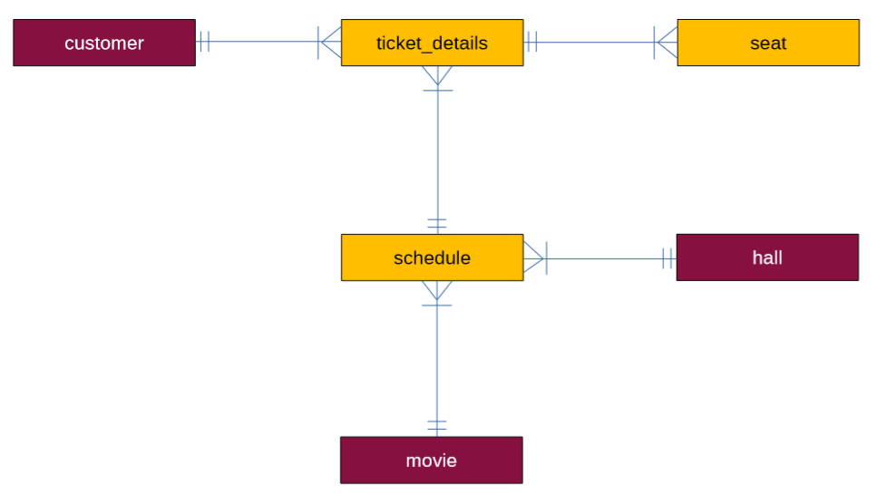

**Task 4: Develop Database Design Language (DBDL)**

**DBDL**

Customer (user_id, username, password, name, age, contact, email, birth_date)

Movie (movie_id, name, age_restricted, genre)

hall (hall_id, name, max_row_seat, max_col_seat)

ticket_details (ticket_id, user_id*, schedule_id*, purchased_datetime, adult_quantity, child_quantity, total_amount)

Schedule (schedule_id, movie_id*, hall_id*, datetime_display)

seat (seat_id, ticket_id*, row_seat, col_seat)

**Task 5: Create database tables in Oracle**

/* CUSTOMER TABLE */

CREATE TABLE customer (

user_id NUMBER(3),

username VARCHAR(20),

password VARCHAR(20),

name VARCHAR(20),

age NUMBER(3),

contact VARCHAR(13),

email VARCHAR(30),

birth_date DATE(0),

PRIMARY KEY (user_id)

);

/* MOVIE TABLE */

CREATE TABLE movie (

movie_id NUMBER(2),

name VARCHAR(30),

age_restricted VARCHAR(16),

genre VARCHAR(20),

PRIMARY KEY (movie_id)

);

/* HALL TABLE */

CREATE TABLE hall (

hall_id NUMBER(2),

name VARCHAR(10),

max_row_seat NUMBER(2),

max_col_seat NUMBER(2),

PRIMARY KEY (hall_id)

);

/* SCHEDULE TABLE */

CREATE TABLE schedule (

schedule_id NUMBER(2),

movie_id NUMBER(2),

hall_id NUMBER(2),

datetime_display TIMESTAMP(0),

PRIMARY KEY (schedule_id),

FOREIGN KEY (movie_id) REFERENCES movie(movie_id),

FOREIGN KEY (hall_id) REFERENCES hall(hall_id)

);

/* TICKET_DETAILS TABLE */

CREATE TABLE ticket_details (

ticket_id NUMBER(2),

user_id NUMBER(2),

schedule_id NUMBER(2),

purchased_datetime TIMESTAMP(0),

adult_quantity NUMBER(2),

child_quantity NUMBER(2),

total_amount NUMBER(5,2),

PRIMARY KEY (ticket_id),

FOREIGN KEY (user_id) REFERENCES customer(user_id),

FOREIGN KEY (schedule_id) REFERENCES schedule(schedule_id)

);

/* SEAT TABLE */

CREATE TABLE seat (

seat_id NUMBER(3),

ticket_id NUMBER(2),

row_seat NUMBER(2),

col_seat NUMBER(2),

PRIMARY KEY (seat_id),

FOREIGN KEY (ticket_id) REFERENCES ticket_details(ticket_id)

);

**Task 6**

/*Insert Customer*/

INSERT INTO customer VALUES (1, 'felix1989', 'pewds123', 'Felix Shellberg', 29, '012-5555555', 'felix1989@gmail.com', '24-OCT-1989');

INSERT INTO customer VALUES (2, 'mark1984', 'fbtime2000', 'Mark Zuckerberg', 35, '011-2783229', 'mark1984@gmail.com', '14-MAY-1984');

INSERT INTO customer VALUES (3, 'gunslinger_101', 'badass666', 'John Wick', 31, '014-5432222', 'john1988@gmail.com', '07-AUG-1988');

INSERT INTO customer VALUES (4, 'robotics231', 'pantsycode22', 'Alita Wong', 18, '018-9922321', 'alita-wong@gmail.com', '01-MAR-2001');

INSERT INTO customer VALUES (5, 'tw1956', 'tommy1956', 'Tommy Wiseau', 63, '018-2222733', 'tw1974@gmail.com', '03-OCT-1989');

INSERT INTO customer VALUES (6, 'leecoach', 'mrlee123', 'Lee Rodgers', 16, '010-5435549', 'lee-coach@gmail.com', '10-JUL-2003');

INSERT INTO customer VALUES (7, 'wakanda', 'nipponpaint4', 'George Lewis', 14, '016-2231636', 'george-lewis@gmail.com', '01-APR-2005');

INSERT INTO customer VALUES (8, 'kingoflion', 'lionking2', 'Issac Tan', 25, '014-3569843', 'issac-tan123@gmail.com', '03-MAY-1994');

INSERT INTO customer VALUES (9, 'evanong', 'ong333', 'Evan Ong', 22, '011-2396608', 'evan1997@gmail.com', '12-DEC-1997');

INSERT INTO customer VALUES (10, 'casonc22', 'cason1997', 'Cason Chandler', 61, '019-9986575', 'cason-chandler@gmail.com', '10-NOV-1958');

INSERT INTO customer VALUES (11, 'firedragon2018', 'xtoothlessx123', 'Ella Howell', 53, '018-9431636', 'ella-howell@gmail.com', '30-JUN-1966');

INSERT INTO customer VALUES (12, 'chucky2019', 'friendforever123', 'Madelyn Davidson', 23, '014-2227475', 'davidson1996@gmail.com', '22-JUL-1996');

INSERT INTO customer VALUES (13, 'spirderman', 'spider999', 'Tom Holland', 23, '015-1314520', 'tomspider@gmail.com', '01-JUN-1996');

INSERT INTO customer VALUES (14, 'creeper', 'awman', 'Captain Sparklez', 27, '012-9322231', 'Sparklez123@gmail.com', '10-FEB-1992');

INSERT INTO customer VALUES (15, 'storming', 'area51', 'Priscilla', 19, '011-8283995', 'pris2000@gmail.com', '21-JAN-2000');

INSERT INTO customer VALUES (16, 'minecrafter', 'minecraftforlife', 'Colin Junior', 34, '011-2345666', 'colin-jr@gmail.com', '08-APR-1985');

INSERT INTO customer VALUES (17, 'cyberpunk2077', 'breathtaking123', 'Keanu Reeves', 54, '014-2321543', 'keanu-reeves1965@gmail.com', '02-SEP-1965');

INSERT INTO customer VALUES (18, 'robinson123', 'dean123', 'Dean Robinson', 33, '016-2356994', 'dean-robinson123@gmail.com', '26-FEB-1986');

INSERT INTO customer VALUES (19, 'taobao', 'millinaire', 'Zack Ma', 54, '018-8965746', 'zack-ma@gmail.com', '15-SEP-1965');

INSERT INTO customer VALUES (20, 'worldtech', 'microsoft', 'Bill Gates', 63, '014-8585222', 'bill-gates1956@gmail.com', '28-OCT-1955');

/* Insert Hall */

INSERT INTO hall VALUES (1, 'Hall 1', 30, 25);

INSERT INTO hall VALUES (2, 'Hall 2', 25, 20);

INSERT INTO hall VALUES (3, 'Hall 3', 25, 20);

INSERT INTO hall VALUES (4, 'Hall 4', 20, 15);

INSERT INTO hall VALUES (5, 'Hall 5', 20, 15);

/*Insert Movie*/

INSERT INTO movie VALUES(1, 'Avengers: Endgame', 'PG', 'Action');

INSERT INTO movie VALUES(2, 'The Lion King', 'PG', 'Fantasy');

INSERT INTO movie VALUES(3, 'Alita: Battle Angel', 'PG-13', 'Sci-Fi');

INSERT INTO movie VALUES(4, 'Toy Story', 'G', 'Fantasy');

INSERT INTO movie VALUES(5, 'John Wick 3', 'PG-13', 'Action');

/* Insert Schedule */

INSERT INTO schedule VALUES (1, 1, 1, '01-JUL-2019 10:30:00');

INSERT INTO schedule VALUES (2, 1, 1, '01-JUL-2019 15:00:00');

INSERT INTO schedule VALUES (3, 1, 1, '01-JUL-2019 19:00:00');

INSERT INTO schedule VALUES (4, 1, 1, '01-JUL-2019 23:00:00');

INSERT INTO schedule VALUES (5, 2, 2, '01-JUL-2019 11:30:00');

INSERT INTO schedule VALUES (6, 2, 2, '01-JUL-2019 14:30:00');

INSERT INTO schedule VALUES (7, 2, 2, '01-JUL-2019 18:00:00');

INSERT INTO schedule VALUES (8, 2, 2, '01-JUL-2019 20:45:00');

INSERT INTO schedule VALUES (9, 3, 3, '01-JUL-2019 10:00:00');

INSERT INTO schedule VALUES (10, 3, 3, '01-JUL-2019 13:15:00');

INSERT INTO schedule VALUES (11, 3, 3, '01-JUL-2019 16:30:00');

INSERT INTO schedule VALUES (12, 3, 3, '01-JUL-2019 19:30:00');

INSERT INTO schedule VALUES (13, 3, 3, '01-JUL-2019 22:30:00');

INSERT INTO schedule VALUES (14, 4, 4, '01-JUL-2019 11:00:00');

INSERT INTO schedule VALUES (15, 4, 4, '01-JUL-2019 14:00:00');

INSERT INTO schedule VALUES (16, 4, 4, '01-JUL-2019 17:30:00');

INSERT INTO schedule VALUES (17, 4, 4, '01-JUL-2019 21:00:00');

INSERT INTO schedule VALUES (18, 5, 5, '01-JUL-2019 09:30:00');

INSERT INTO schedule VALUES (19, 5, 5, '01-JUL-2019 12:30:00');

INSERT INTO schedule VALUES (20, 5, 5, '01-JUL-2019 16:00:00');

INSERT INTO schedule VALUES (21, 5, 5, '01-JUL-2019 20:00:00');

INSERT INTO schedule VALUES (22, 5, 5, '01-JUL-2019 22:55:00');

INSERT INTO schedule VALUES (23, 1, 1, '02-JUL-2019 10:00:00');

INSERT INTO schedule VALUES (24, 1, 1, '02-JUL-2019 13:45:00');

INSERT INTO schedule VALUES (25, 2, 1, '02-JUL-2019 17:30:00');

INSERT INTO schedule VALUES (26, 2, 1, '02-JUL-2019 20:15:00');

INSERT INTO schedule VALUES (27, 5, 1, '02-JUL-2019 22:55:00');

INSERT INTO schedule VALUES (28, 1, 2, '02-JUL-2019 10:30:00');

INSERT INTO schedule VALUES (29, 1, 2, '02-JUL-2019 14:15:00');

INSERT INTO schedule VALUES (30, 3, 2, '02-JUL-2019 16:45:00');

INSERT INTO schedule VALUES (31, 4, 2, '02-JUL-2019 19:30:00');

INSERT INTO schedule VALUES (32, 5, 2, '02-JUL-2019 23:00:00');

INSERT INTO schedule VALUES (33, 3, 3, '02-JUL-2019 09:45:00');

INSERT INTO schedule VALUES (34, 4, 3, '02-JUL-2019 12:30:00');

INSERT INTO schedule VALUES (35, 1, 3, '02-JUL-2019 15:30:00');

INSERT INTO schedule VALUES (36, 1, 3, '02-JUL-2019 19:45:00');

INSERT INTO schedule VALUES (37, 1, 3, '02-JUL-2019 23:15:00');

INSERT INTO schedule VALUES (38, 5, 4, '02-JUL-2019 11:30:00');

INSERT INTO schedule VALUES (39, 5, 4, '02-JUL-2019 14:15:00');

INSERT INTO schedule VALUES (40, 3, 4, '02-JUL-2019 17:00:00');

INSERT INTO schedule VALUES (41, 3, 4, '02-JUL-2019 19:55:00');

INSERT INTO schedule VALUES (42, 2, 4, '02-JUL-2019 22:45:00');

INSERT INTO schedule VALUES (43, 2, 5, '02-JUL-2019 11:00:00');

INSERT INTO schedule VALUES (44, 2, 5, '02-JUL-2019 14:00:00');

INSERT INTO schedule VALUES (45, 4, 5, '02-JUL-2019 16:45:00');

INSERT INTO schedule VALUES (46, 4, 5, '02-JUL-2019 19:30:00');

INSERT INTO schedule VALUES (47, 4, 5, '02-JUL-2019 22:15:00');

INSERT INTO schedule VALUES (48, 3, 1, '03-JUL-2019 11:15:00');

INSERT INTO schedule VALUES (49, 4, 1, '03-JUL-2019 14:00:00');

INSERT INTO schedule VALUES (50, 1, 1, '03-JUL-2019 17:00:00');

INSERT INTO schedule VALUES (51, 3, 1, '03-JUL-2019 20:45:00');

INSERT INTO schedule VALUES (52, 5, 1, '03-JUL-2019 23:30:00');

INSERT INTO schedule VALUES (53, 2, 2, '03-JUL-2019 10:15:00');

INSERT INTO schedule VALUES (54, 3, 2, '03-JUL-2019 12:55:00');

INSERT INTO schedule VALUES (55, 5, 2, '03-JUL-2019 15:45:00');

INSERT INTO schedule VALUES (56, 5, 2, '03-JUL-2019 18:55:00');

INSERT INTO schedule VALUES (57, 1, 2, '03-JUL-2019 21:45:00');

INSERT INTO schedule VALUES (58, 1, 3, '03-JUL-2019 10:30:00');

INSERT INTO schedule VALUES (59, 1, 3, '03-JUL-2019 14:00:00');

INSERT INTO schedule VALUES (60, 2, 3, '03-JUL-2019 17:45:00');

INSERT INTO schedule VALUES (61, 4, 3, '03-JUL-2019 20:45:00');

INSERT INTO schedule VALUES (62, 5, 4, '03-JUL-2019 10:45:00');

INSERT INTO schedule VALUES (63, 4, 4, '03-JUL-2019 14:00:00');

INSERT INTO schedule VALUES (64, 3, 4, '03-JUL-2019 16:55:00');

INSERT INTO schedule VALUES (65, 1, 4, '03-JUL-2019 20:15:00');

INSERT INTO schedule VALUES (66, 2, 5, '03-JUL-2019 09:45:00');

INSERT INTO schedule VALUES (67, 5, 5, '03-JUL-2019 12:00:00');

INSERT INTO schedule VALUES (68, 3, 5, '03-JUL-2019 14:45:00');

INSERT INTO schedule VALUES (69, 1, 5, '03-JUL-2019 17:45:00');

INSERT INTO schedule VALUES (70, 2, 5, '03-JUL-2019 21:30:00');

INSERT INTO schedule VALUES (71, 5, 5, '03-JUL-2019 23:55:00');

/* Insert Seat */

INSERT INTO seat VALUES (1, 1, 1, 1);

INSERT INTO seat VALUES (2, 1, 1, 2);

INSERT INTO seat VALUES (3, 1, 1, 3);

INSERT INTO seat VALUES (4, 2, 1, 4);

INSERT INTO seat VALUES (5, 2, 1, 5);

INSERT INTO seat VALUES (6, 2, 1, 6);

INSERT INTO seat VALUES (7, 2, 1, 7);

INSERT INTO seat VALUES (8, 2, 1, 8);

INSERT INTO seat VALUES (9, 3, 1, 9);

INSERT INTO seat VALUES (10, 3, 1, 10);

INSERT INTO seat VALUES (11, 4, 1, 11);

INSERT INTO seat VALUES (12, 4, 1, 12);

INSERT INTO seat VALUES (13, 4, 1, 13);

INSERT INTO seat VALUES (14, 4, 1, 14);

INSERT INTO seat VALUES (15, 5, 1, 15);

INSERT INTO seat VALUES (16, 5, 1, 16);

INSERT INTO seat VALUES (17, 5, 1, 17);

INSERT INTO seat VALUES (18, 6, 2, 1);

INSERT INTO seat VALUES (19, 6, 2, 2);

INSERT INTO seat VALUES (20, 6, 2, 3);

INSERT INTO seat VALUES (21, 6, 2, 4);

INSERT INTO seat VALUES (22, 6, 2, 5);

INSERT INTO seat VALUES (23, 7, 2, 6);

INSERT INTO seat VALUES (24, 7, 2, 7);

INSERT INTO seat VALUES (25, 7, 2, 8);

INSERT INTO seat VALUES (26, 7, 2, 9);

INSERT INTO seat VALUES (27, 7, 2, 10);

INSERT INTO seat VALUES (28, 7, 2, 11);

INSERT INTO seat VALUES (29, 7, 2, 12);

INSERT INTO seat VALUES (30, 8, 2, 13);

INSERT INTO seat VALUES (31, 8, 2, 14);

INSERT INTO seat VALUES (32, 9, 2, 15);

INSERT INTO seat VALUES (33, 9, 2, 16);

INSERT INTO seat VALUES (34, 10, 2, 17);

INSERT INTO seat VALUES (35, 10, 2, 18);

INSERT INTO seat VALUES (36, 10, 2, 19);

INSERT INTO seat VALUES (37, 10, 2, 20);

INSERT INTO seat VALUES (38, 10, 2, 21);

INSERT INTO seat VALUES (39, 11, 3, 1);

INSERT INTO seat VALUES (40, 11, 3, 2);

INSERT INTO seat VALUES (41, 11, 3, 3);

INSERT INTO seat VALUES (42, 12, 3, 4);

INSERT INTO seat VALUES (43, 12, 3, 5);

INSERT INTO seat VALUES (44, 12, 3, 6);

INSERT INTO seat VALUES (45, 13, 3, 7);

INSERT INTO seat VALUES (46, 13, 3, 8);

INSERT INTO seat VALUES (47, 13, 3, 9);

INSERT INTO seat VALUES (48, 13, 3, 10);

INSERT INTO seat VALUES (49, 14, 3, 11);

INSERT INTO seat VALUES (50, 15, 3, 12);

INSERT INTO seat VALUES (51, 15, 3, 13);

INSERT INTO seat VALUES (52, 15, 3, 14);

INSERT INTO seat VALUES (53, 16, 3, 15);

INSERT INTO seat VALUES (54, 16, 4, 1);

INSERT INTO seat VALUES (55, 16, 4, 2);

INSERT INTO seat VALUES (56, 17, 4, 3);

INSERT INTO seat VALUES (57, 17, 4, 4);

INSERT INTO seat VALUES (58, 17, 4, 5);

INSERT INTO seat VALUES (59, 18, 4, 6);

INSERT INTO seat VALUES (60, 18, 4, 7);

INSERT INTO seat VALUES (61, 19, 4, 8);

INSERT INTO seat VALUES (62, 19, 4, 9);

INSERT INTO seat VALUES (63, 19, 4, 10);

INSERT INTO seat VALUES (64, 19, 4, 11);

INSERT INTO seat VALUES (65, 20, 4, 12);

INSERT INTO seat VALUES (66, 20, 4, 13);

INSERT INTO seat VALUES (67, 20, 4, 14);

INSERT INTO seat VALUES (68, 20, 4, 15);

INSERT INTO seat VALUES (69, 21, 4, 16);

INSERT INTO seat VALUES (70, 21, 4, 17);

INSERT INTO seat VALUES (71, 21, 4, 18);

INSERT INTO seat VALUES (72, 21, 4, 19);

INSERT INTO seat VALUES (73, 21, 4, 20);

INSERT INTO seat VALUES (74, 21, 5, 1);

INSERT INTO seat VALUES (75, 22, 5, 2);

INSERT INTO seat VALUES (76, 22, 5, 3);

INSERT INTO seat VALUES (77, 22, 5, 4);

INSERT INTO seat VALUES (78, 22, 5, 5);

INSERT INTO seat VALUES (79, 22, 5, 6);

INSERT INTO seat VALUES (80, 22, 5, 7);

INSERT INTO seat VALUES (81, 23, 5, 8);

INSERT INTO seat VALUES (82, 24, 5, 12);

INSERT INTO seat VALUES (83, 24, 5, 10);

INSERT INTO seat VALUES (84, 24, 5, 11);

INSERT INTO seat VALUES (85, 24, 5, 12);

INSERT INTO seat VALUES (86, 24, 5, 13);

INSERT INTO seat VALUES (87, 25, 5, 14);

INSERT INTO seat VALUES (88, 25, 5, 15);

INSERT INTO seat VALUES (89, 25, 6, 1);

INSERT INTO seat VALUES (90, 25, 6, 2);

INSERT INTO seat VALUES (91, 25, 6, 3);

INSERT INTO seat VALUES (92, 25, 6, 4);

INSERT INTO seat VALUES (93, 25, 6, 5);

INSERT INTO seat VALUES (94, 25, 6, 6);

INSERT INTO seat VALUES (95, 25, 6, 7);

INSERT INTO seat VALUES (96, 26, 6, 8);

INSERT INTO seat VALUES (97, 26, 6, 9);

INSERT INTO seat VALUES (98, 26, 6, 10);

INSERT INTO seat VALUES (99, 26, 6, 11);

INSERT INTO seat VALUES (100, 27, 6, 12);

INSERT INTO seat VALUES (101, 27, 6, 13);

INSERT INTO seat VALUES (102, 27, 6, 14);

INSERT INTO seat VALUES (103, 28, 6, 15);

INSERT INTO seat VALUES (104, 28, 7, 1);

INSERT INTO seat VALUES (105, 28, 7, 2);

INSERT INTO seat VALUES (106, 28, 7, 3);

INSERT INTO seat VALUES (107, 29, 7, 4);

INSERT INTO seat VALUES (108, 29, 7, 5);

INSERT INTO seat VALUES (109, 30, 7, 6);

INSERT INTO seat VALUES (110, 30, 7, 7);

INSERT INTO seat VALUES (111, 30, 7, 8);

INSERT INTO seat VALUES (112, 30, 7, 9);

INSERT INTO seat VALUES (113, 30, 7, 10);

INSERT INTO seat VALUES (114, 30, 7, 11);

INSERT INTO seat VALUES (115, 30, 7, 12);

INSERT INTO seat VALUES (116, 30, 7, 13);

INSERT INTO seat VALUES (117, 31, 7, 14);

INSERT INTO seat VALUES (118, 31, 7, 15);

INSERT INTO seat VALUES (119, 31, 7, 16);

INSERT INTO seat VALUES (120, 31, 7, 17);

INSERT INTO seat VALUES (121, 31, 7, 18);

INSERT INTO seat VALUES (122, 32, 7, 19);

INSERT INTO seat VALUES (123, 32, 7, 20);

INSERT INTO seat VALUES (124, 32, 8, 1);

INSERT INTO seat VALUES (125, 33, 8, 2);

INSERT INTO seat VALUES (126, 33, 8, 3);

INSERT INTO seat VALUES (127, 33, 8, 4);

INSERT INTO seat VALUES (128, 33, 8, 5);

INSERT INTO seat VALUES (129, 33, 8, 6);

INSERT INTO seat VALUES (130, 34, 8, 7);

INSERT INTO seat VALUES (131, 34, 8, 8);

INSERT INTO seat VALUES (132, 34, 8, 9);

INSERT INTO seat VALUES (133, 34, 8, 10);

INSERT INTO seat VALUES (134, 34, 8, 11);

INSERT INTO seat VALUES (135, 35, 8, 12);

INSERT INTO seat VALUES (136, 35, 8, 13);

INSERT INTO seat VALUES (137, 35, 8, 14);

INSERT INTO seat VALUES (138, 35, 8, 15);

INSERT INTO seat VALUES (139, 35, 8, 16);

INSERT INTO seat VALUES (140, 36, 8, 17);

INSERT INTO seat VALUES (141, 36, 8, 18);

INSERT INTO seat VALUES (142, 36, 8, 19);

INSERT INTO seat VALUES (143, 36, 8, 20);

INSERT INTO seat VALUES (144, 36, 9, 1);

INSERT INTO seat VALUES (145, 36, 9, 2);

INSERT INTO seat VALUES (146, 36, 9, 3);

INSERT INTO seat VALUES (147, 36, 9, 4);

INSERT INTO seat VALUES (148, 36, 9, 5);

INSERT INTO seat VALUES (149, 37, 9, 6);

INSERT INTO seat VALUES (150, 37, 9, 7);

INSERT INTO seat VALUES (151, 38, 9, 8);

INSERT INTO seat VALUES (152, 39, 9, 9);

INSERT INTO seat VALUES (153, 39, 9, 10);

INSERT INTO seat VALUES (154, 39, 9, 11);

INSERT INTO seat VALUES (155, 39, 9, 12);

INSERT INTO seat VALUES (156, 39, 9, 13);

INSERT INTO seat VALUES (157, 40, 9, 14);

INSERT INTO seat VALUES (158, 40, 9, 15);

INSERT INTO seat VALUES (159, 40, 10, 1);

INSERT INTO seat VALUES (160, 40, 10, 2);

INSERT INTO seat VALUES (161, 40, 10, 3);

INSERT INTO seat VALUES (162, 41, 10, 4);

INSERT INTO seat VALUES (163, 41, 10, 5);

INSERT INTO seat VALUES (164, 41, 10, 6);

INSERT INTO seat VALUES (165, 41, 10, 7);

INSERT INTO seat VALUES (166, 41, 10, 8);

INSERT INTO seat VALUES (167, 41, 10, 9);

INSERT INTO seat VALUES (168, 42, 10, 10);

INSERT INTO seat VALUES (169, 42, 10, 11);

INSERT INTO seat VALUES (170, 43, 10, 12);

INSERT INTO seat VALUES (171, 43, 10, 13);

INSERT INTO seat VALUES (172, 43, 10, 14);

INSERT INTO seat VALUES (173, 44, 10, 15);

INSERT INTO seat VALUES (174, 45, 1, 1);

INSERT INTO seat VALUES (175, 45, 1, 2);

INSERT INTO seat VALUES (176, 45, 1, 3);

INSERT INTO seat VALUES (177, 45, 1, 4);

INSERT INTO seat VALUES (178, 46, 1, 5);

INSERT INTO seat VALUES (179, 46, 1, 6);

INSERT INTO seat VALUES (180, 47, 1, 7);

INSERT INTO seat VALUES (181, 47, 1, 8);

INSERT INTO seat VALUES (182, 48, 1, 9);

INSERT INTO seat VALUES (183, 48, 1, 10);

INSERT INTO seat VALUES (184, 48, 1, 11);

INSERT INTO seat VALUES (185, 48, 1, 12);

INSERT INTO seat VALUES (186, 48, 1, 13);

INSERT INTO seat VALUES (187, 49, 1, 14);

INSERT INTO seat VALUES (188, 49, 1, 15);

INSERT INTO seat VALUES (189, 49, 2, 1);

INSERT INTO seat VALUES (190, 49, 2, 2);

INSERT INTO seat VALUES (191, 50, 2, 3);

INSERT INTO seat VALUES (192, 50, 2, 4);

INSERT INTO seat VALUES (193, 51, 2, 5);

INSERT INTO seat VALUES (194, 52, 2, 6);

INSERT INTO seat VALUES (195, 52, 2, 7);

INSERT INTO seat VALUES (196, 53, 2, 8);

INSERT INTO seat VALUES (197, 53, 2, 9);

INSERT INTO seat VALUES (198, 53, 2, 10);

INSERT INTO seat VALUES (199, 53, 2, 11);

INSERT INTO seat VALUES (200, 53, 2, 12);

INSERT INTO seat VALUES (201, 54, 2, 13);

INSERT INTO seat VALUES (202, 54, 2, 14);

INSERT INTO seat VALUES (203, 54, 2, 15);

INSERT INTO seat VALUES (204, 54, 3, 1);

INSERT INTO seat VALUES (205, 55, 3, 2);

INSERT INTO seat VALUES (206, 55, 3, 3);

INSERT INTO seat VALUES (207, 56, 3, 4);

INSERT INTO seat VALUES (208, 56, 3, 5);

INSERT INTO seat VALUES (209, 56, 3, 6);

INSERT INTO seat VALUES (210, 57, 3, 7);

INSERT INTO seat VALUES (211, 57, 3, 8);

INSERT INTO seat VALUES (212, 57, 3, 9);

INSERT INTO seat VALUES (213, 57, 3, 10);

INSERT INTO seat VALUES (214, 57, 3, 11);

INSERT INTO seat VALUES (215, 57, 3, 12);

INSERT INTO seat VALUES (216, 58, 3, 13);

INSERT INTO seat VALUES (217, 58, 3, 14);

INSERT INTO seat VALUES (218, 58, 3, 15);

INSERT INTO seat VALUES (219, 59, 4, 1);

INSERT INTO seat VALUES (220, 60, 4, 2);

INSERT INTO seat VALUES (221, 61, 4, 3);

INSERT INTO seat VALUES (222, 61, 4, 4);

INSERT INTO seat VALUES (223, 61, 4, 5);

INSERT INTO seat VALUES (224, 61, 4, 6);

INSERT INTO seat VALUES (225, 62, 4, 7);

INSERT INTO seat VALUES (226, 62, 4, 8);

INSERT INTO seat VALUES (227, 62, 4, 9);

INSERT INTO seat VALUES (228, 62, 4, 10);

INSERT INTO seat VALUES (229, 63, 4, 11);

INSERT INTO seat VALUES (230, 63, 4, 12);

INSERT INTO seat VALUES (231, 63, 4, 13);

INSERT INTO seat VALUES (232, 63, 4, 14);

INSERT INTO seat VALUES (233, 63, 4, 15);

INSERT INTO seat VALUES (234, 63, 5, 1);

INSERT INTO seat VALUES (235, 64, 5, 2);

INSERT INTO seat VALUES (236, 64, 5, 3);

INSERT INTO seat VALUES (237, 64, 5, 4);

INSERT INTO seat VALUES (238, 65, 5, 5);

INSERT INTO seat VALUES (239, 65, 5, 6);

INSERT INTO seat VALUES (240, 65, 5, 7);

INSERT INTO seat VALUES (241, 66, 5, 8);

INSERT INTO seat VALUES (242, 66, 5, 9);

INSERT INTO seat VALUES (243, 66, 5, 10);

INSERT INTO seat VALUES (244, 66, 5, 11);

INSERT INTO seat VALUES (245, 66, 5, 12);

INSERT INTO seat VALUES (246, 67, 5, 13);

INSERT INTO seat VALUES (247, 67, 5, 14);

INSERT INTO seat VALUES (248, 67, 5, 15);

INSERT INTO seat VALUES (249, 67, 6, 1);

INSERT INTO seat VALUES (250, 67, 6, 2);

INSERT INTO seat VALUES (251, 67, 6, 3);

INSERT INTO seat VALUES (252, 68, 6, 4);

INSERT INTO seat VALUES (253, 68, 6, 5);

INSERT INTO seat VALUES (254, 68, 6, 6);

INSERT INTO seat VALUES (255, 68, 6, 7);

INSERT INTO seat VALUES (256, 69, 6, 8);

INSERT INTO seat VALUES (257, 69, 6, 9);

INSERT INTO seat VALUES (258, 70, 6, 10);

INSERT INTO seat VALUES (259, 70, 6, 11);

/* Insert Ticket_Details */

INSERT INTO ticket_details VALUES (1, 20, 2, '17-JUN-2019 14:14:32', 2, 1, 39.00);

INSERT INTO ticket_details VALUES (2, 18, 4, '17-JUN-2019 15:13:21', 3, 2, 63.00);

INSERT INTO ticket_details VALUES (3, 11, 6, '18-JUN-2019 11:12:25', 2, 0, 30.00);

INSERT INTO ticket_details VALUES (4, 12, 12, '18-JUN-2019 12:20:41', 4, 0, 60.00);

INSERT INTO ticket_details VALUES (5, 14, 10, '18-JUN-2019 13:51:21', 3, 0, 45.00);

INSERT INTO ticket_details VALUES (6, 13, 14, '18-JUN-2019 14:20:21', 0, 5, 45.00);

INSERT INTO ticket_details VALUES (7, 10, 8, '18-JUN-2019 15:39:55', 5, 2, 93.00);

INSERT INTO ticket_details VALUES (8, 8, 7, '18-JUN-2019 18:45:44', 1, 1, 24.00);

INSERT INTO ticket_details VALUES (9, 1, 1, '18-JUN-2019 20:22:15', 1, 1, 24.00);

INSERT INTO ticket_details VALUES (10, 3, 3, '18-JUN-2019 22:41:56', 2, 3, 57.00);

INSERT INTO ticket_details VALUES (11, 2, 15, '19-JUN-2019 11:11:13', 1, 2, 33.00);

INSERT INTO ticket_details VALUES (12, 4, 13, '19-JUN-2019 12:10:11', 3, 0, 45.00);

INSERT INTO ticket_details VALUES (13, 7, 5, '19-JUN-2019 12:55:53', 2, 2, 48.00);

INSERT INTO ticket_details VALUES (14, 6, 9, '19-JUN-2019 15:33:45', 1, 0, 15.00);

INSERT INTO ticket_details VALUES (15, 5, 17, '19-JUN-2019 17:18:21', 2, 1, 39.00);

INSERT INTO ticket_details VALUES (16, 15, 16, '19-JUN-2019 19:21:22', 2, 1, 39.00);

INSERT INTO ticket_details VALUES (17, 9, 70, '20-JUN-2019 15:11:10', 3, 0, 45.00);

INSERT INTO ticket_details VALUES (18, 17, 20, '20-JUN-2019 18:16:57', 2, 0, 30.00);

INSERT INTO ticket_details VALUES (19, 16, 18, '20-JUN-2019 23:11:43', 4, 0, 60.00);

INSERT INTO ticket_details VALUES (20, 19, 19, '21-JUN-2019 16:44:12', 4, 0, 60.00);

INSERT INTO ticket_details VALUES (21, 1, 30, '21-JUN-2019 21:58:32', 6, 0, 90.00);

INSERT INTO ticket_details VALUES (22, 5, 28, '22-JUN-2019 10:34:22', 2, 4, 66.00);

INSERT INTO ticket_details VALUES (23, 6, 21, '22-JUN-2019 12:48:23', 1, 0, 15.00);

INSERT INTO ticket_details VALUES (24, 8, 10, '22-JUN-2019 18:44:17', 5, 0, 75.00);

INSERT INTO ticket_details VALUES (25, 10, 22, '22-JUN-2019 22:40:36', 9, 0, 135.00);

INSERT INTO ticket_details VALUES (26, 12, 16, '23-JUN-2019 13:11:49', 1, 3, 42.00);

INSERT INTO ticket_details VALUES (27, 14, 15, '23-JUN-2019 18:56:27', 1, 2, 33.00);

INSERT INTO ticket_details VALUES (28, 13, 48, '23-JUN-2019 20:40:20', 3, 1, 54.00);

INSERT INTO ticket_details VALUES (29, 15, 50, '23-JUN-2019 23:10:33', 2, 0, 30.00);

INSERT INTO ticket_details VALUES (30, 11, 31, '23-JUN-2019 23:54:21', 3, 5, 90.00);

INSERT INTO ticket_details VALUES (31, 16, 56, '24-JUN-2019 11:58:41', 3, 2, 63.00);

INSERT INTO ticket_details VALUES (32, 2, 37, '24-JUN-2019 16:13:21', 3, 0, 45.00);

INSERT INTO ticket_details VALUES (33, 3, 68, '24-JUN-2019 17:08:09', 3, 2, 63.00);

INSERT INTO ticket_details VALUES (34, 17, 66, '24-JUN-2019 19:59:51', 5, 0, 75.00);

INSERT INTO ticket_details VALUES (35, 4, 52, '25-JUN-2019 12:20:41', 5, 0, 75.00);

INSERT INTO ticket_details VALUES (36, 19, 55, '25-JUN-2019 18:21:21', 7, 2, 123.00);

INSERT INTO ticket_details VALUES (37, 18, 67, '25-JUN-2019 22:56:38', 2, 0, 30.00);

INSERT INTO ticket_details VALUES (38, 7, 70, '26-JUN-2019 09:56:00', 1, 0, 15.00);

INSERT INTO ticket_details VALUES (39, 20, 44, '26-JUN-2019 11:23:02', 2, 3, 57.00);

INSERT INTO ticket_details VALUES (40, 9, 40, '26-JUN-2019 15:18:10', 5, 0, 75.00);

INSERT INTO ticket_details VALUES (41, 3, 29, '26-JUN-2019 17:16:16', 2, 4, 66.00);

INSERT INTO ticket_details VALUES (42, 8, 27, '26-JUN-2019 21:08:02', 2, 0, 30.00);

INSERT INTO ticket_details VALUES (43, 2, 20, '26-JUN-2019 22:06:01', 3, 0, 45.00);

INSERT INTO ticket_details VALUES (44, 1, 54, '27-JUN-2019 10:56:32', 1, 0, 15.00);

INSERT INTO ticket_details VALUES (45, 7, 50, '27-JUN-2019 11:01:09', 4, 0, 60.00);

INSERT INTO ticket_details VALUES (46, 9, 20, '27-JUN-2019 13:15:19', 2, 0, 30.00);

INSERT INTO ticket_details VALUES (47, 12, 18, '27-JUN-2019 14:30:32', 2, 0, 30.00);

INSERT INTO ticket_details VALUES (48, 18, 16, '27-JUN-2019 15:11:50', 4, 1, 69.00);

INSERT INTO ticket_details VALUES (49, 11, 59, '27-JUN-2019 19:20:11', 2, 2, 48.00);

INSERT INTO ticket_details VALUES (50, 13, 62, '28-JUN-2019 11:00:00', 1, 1, 24.00);

INSERT INTO ticket_details VALUES (51, 19, 64, '28-JUN-2019 14:20:44', 1, 0, 15.00);

INSERT INTO ticket_details VALUES (52, 4, 66, '28-JUN-2019 16:11:32', 2, 0, 30.00);

INSERT INTO ticket_details VALUES (53, 10, 11, '28-JUN-2019 16:55:11', 5, 0, 75.00);

INSERT INTO ticket_details VALUES (54, 6, 24, '28-JUN-2019 18:43:56', 1, 3, 42.00);

INSERT INTO ticket_details VALUES (55, 14, 51, '28-JUN-2019 22:11:23', 2, 0, 30.00);

INSERT INTO ticket_details VALUES (56, 17, 23, '29-JUN-2019 08:10:11', 1, 2, 33.00);

INSERT INTO ticket_details VALUES (57, 16, 25, '29-JUN-2019 10:21:54', 3, 3, 72.00);

INSERT INTO ticket_details VALUES (58, 15, 28, '29-JUN-2019 11:55:11', 2, 1, 39.00);

INSERT INTO ticket_details VALUES (59, 5, 53, '29-JUN-2019 13:11:21', 1, 0, 15.00);

INSERT INTO ticket_details VALUES (60, 20, 30, '29-JUN-2019 14:34:35', 1, 0, 15.00);

INSERT INTO ticket_details VALUES (61, 2, 33, '29-JUN-2019 16:07:09', 2, 2, 48.00);

INSERT INTO ticket_details VALUES (62, 7, 38, '29-JUN-2019 20:07:04', 1, 3, 42.00);

INSERT INTO ticket_details VALUES (63, 1, 37, '30-JUN-2019 10:00:42', 4, 2, 78.00);

INSERT INTO ticket_details VALUES (64, 3, 36, '30-JUN-2019 13:55:29', 2, 1, 39.00);

INSERT INTO ticket_details VALUES (65, 12, 43, '30-JUN-2019 17:18:29', 2, 1, 39.00);

INSERT INTO ticket_details VALUES (66, 16, 49, '30-JUN-2019 19:00:05', 3, 2, 63.00);

INSERT INTO ticket_details VALUES (67, 5, 70, '30-JUN-2019 20:08:07', 3, 3, 72.00);

INSERT INTO ticket_details VALUES (68, 19, 68, '30-JUN-2019 21:22:41', 2, 2, 48.00);

INSERT INTO ticket_details VALUES (69, 20, 57, '30-JUN-2019 21:53:26', 1, 1, 24.00);

INSERT INTO ticket_details VALUES (70, 13, 69, '30-JUN-2019 22:20:57', 2, 0, 30.00);

**Task 7: Create Queries**

**Team member:** Ong Yi Pin

**1st Query**

**QUERY**

column customer_spending_RM format 999.00

cl scr

/* Ong Yi Pin Queries 1*/

PROMPT Input the customer name to show the total amount of spending.

PROMPT

PROMPT

ACCEPT v_name char FORMAT 'A25' PROMPT 'Enter Customer Name: '

SELECT C.name AS customer_name, SUM(TD.total_amount) AS customer_spending_RM

FROM customer C, ticket_details TD

WHERE TD.user_id = C.user_id

AND C.name = '&v_name'

GROUP BY C.name;

clear column;

clear break;

**OUTPUT**

SQL> start C:\ongyipin_1.txt;

Input the customer name to show the total amount of spending.

Enter Customer Name: Keanu Reeves

old 4: AND C.name = '&v_name'

new 4: AND C.name = 'Keanu Reeves'

CUSTOMER_NAME CUSTOMER_SPENDING_RM

-------------------- --------------------

Keanu Reeves 138.00

SQL> spool off

**2nd Query**

**QUERY**

column datetime_display format A30

cl scr

/* Ong Yi Pin Queries 2*/

PROMPT Input the particular hall to show which time and which movie to show up

PROMPT

PROMPT

ACCEPT v_hall char FORMAT 'A25' PROMPT 'Enter Hall Name(Hall 1/2/3/4/5): '

SELECT H.name AS hall_name, M.name AS movie_name, S.datetime_display

FROM hall H, movie M, schedule S

WHERE H.hall_id= S.hall_id

AND M.movie_id = S.movie_id

AND H.name = '&v_hall'

ORDER BY S.datetime_display;

clear column;

clear break;

**OUTPUT**

SQL> start C:\ongyipin_2.txt;

Input the particular hall to show which time and which movie to show up

Enter Hall Name(Hall 1/2/3/4/5): Hall 5

old 5: AND H.name = '&v_hall'

new 5: AND H.name = 'Hall 5'

HALL_NAME MOVIE_NAME DATETIME_DISPLAY

---------- ------------------------------ ------------------------------

Hall 5 John Wick 3 01-JUL-2019 09:30:00

Hall 5 John Wick 3 01-JUL-2019 12:30:00

Hall 5 John Wick 3 01-JUL-2019 16:00:00

Hall 5 John Wick 3 01-JUL-2019 20:00:00

Hall 5 John Wick 3 01-JUL-2019 22:55:00

Hall 5 The Lion King 02-JUL-2019 11:00:00

Hall 5 The Lion King 02-JUL-2019 14:00:00

Hall 5 Toy Story 02-JUL-2019 16:45:00

Hall 5 Toy Story 02-JUL-2019 19:30:00

Hall 5 Toy Story 02-JUL-2019 22:15:00

Hall 5 The Lion King 03-JUL-2019 09:45:00

Hall 5 John Wick 3 03-JUL-2019 12:00:00

Hall 5 Alita: Battle Angel 03-JUL-2019 14:45:00

Hall 5 Avengers: Endgame 03-JUL-2019 17:45:00

Hall 5 The Lion King 03-JUL-2019 21:30:00

Hall 5 John Wick 3 03-JUL-2019 23:55:00

16 rows selected.

SQL> spool off;

**3rd Query**

**QUERY**

column datetime_display format A30

cl scr

/* Ong Yi Pin Queries 3*/

PROMPT Input the particular user to know what time he is entering the specific hall

PROMPT

PROMPT

ACCEPT v_name char FORMAT 'A30' PROMPT 'Enter Customer Name: '

SELECT C.name AS customer_name, S.datetime_display, H.name AS hall_name

FROM customer C, hall H, schedule S, ticket_details TD

WHERE C.user_id = TD.user_id

AND TD.schedule_id = S.schedule_id

AND S.hall_id = H.hall_id

AND C.name = '&v_name';

clear column;

clear break;

**OUTPUT**

SQL> start C:\ongyipin_3.txt;

Input the particular user to know what time he is entering the specific hall

Enter Customer Name: Felix Shellberg

old 6: AND C.name = '&v_name'

new 6: AND C.name = 'Felix Shellberg'

CUSTOMER_NAME DATETIME_DISPLAY HALL_NAME

-------------------- ------------------------------ ----------

Felix Shellberg 01-JUL-19 10.30.00 AM Hall 1

Felix Shellberg 02-JUL-19 04.45.00 PM Hall 2

Felix Shellberg 02-JUL-19 11.15.00 PM Hall 3

Felix Shellberg 03-JUL-19 12.55.00 PM Hall 2

SQL> spool off

**Team member:** Lim Jia Wei

**1st Query**

**QUERY**

column purchased_datetime format A30

cl scr

/* Lim Jia Wei Queries 1*/

PROMPT The User That Start With The Character That You Input To Know Which

PROMPT (customer name, movie, hall, display time, purchased time, adult_quantity, child_quantity)

PROMPT

ACCEPT v_character char FORMAT '99' PROMPT 'Enter a Character to Start With: '

SELECT C.name, M.name AS movie_name, H.name, TD.purchased_datetime, TD.adult_quantity, TD.child_quantity

FROM customer C, movie M, hall H, schedule S, ticket_details TD

WHERE C.name LIKE UPPER('&v_character%')

AND C.user_id = TD.user_id

AND TD.schedule_id = S.schedule_id

AND S.movie_id = M.movie_id

AND S.hall_id = H.hall_id;

clear column;

clear break;

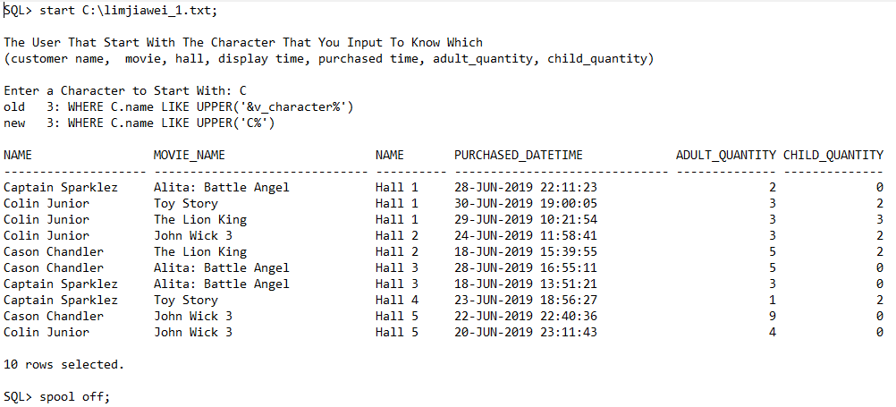**OUTPUT**

**2nd Query**

**QUERY**

column datetime_display format A30

column movie_name format A25

cl scr

/* Lim Jia Wei Queries 2*/

PROMPT Showing the movie between time, date and hall.

PROMPT

PROMPT

ACCEPT v_datetime_min char FORMAT 'A30' PROMPT 'Enter The Minimum Time And Date(DD-MON-YYYY HH:MM:SS): '

ACCEPT v_datetime_max char FORMAT 'A30' PROMPT 'Enter The Maximum Time And Date(DD-MON-YYYY HH:MM:SS): '

SELECT S.datetime_display, M.name AS movie_name, H.name AS hall_name

FROM schedule S, movie M, hall H

WHERE S.datetime_display BETWEEN '&v_datetime_min' AND '&v_datetime_max'

AND S.movie_id = M.movie_id

AND S.hall_id = H.hall_id

ORDER BY S.datetime_display ASC;

clear column;

clear break;

**OUTPUT**

SQL> start C:\limjiawei_2.txt;

Showing the movie between time, date and hall.

Enter The Minimum Time And Date(DD-MON-YYYY HH:MM:SS): 01-JUL-2019 18:00:00

Enter The Maximum Time And Date(DD-MON-YYYY HH:MM:SS): 02-JUL-2019 15:00:00

old 3: WHERE S.datetime_display BETWEEN '&v_datetime_min' AND '&v_datetime_max'

new 3: WHERE S.datetime_display BETWEEN '01-JUL-2019 18:00:00' AND '02-JUL-2019 15:00:00'

DATETIME_DISPLAY MOVIE_NAME HALL_NAME

------------------------------ ------------------------- ----------

01-JUL-2019 18:00:00 The Lion King Hall 2

01-JUL-2019 19:00:00 Avengers: Endgame Hall 1

01-JUL-2019 19:30:00 Alita: Battle Angel Hall 3

01-JUL-2019 20:00:00 John Wick 3 Hall 5

01-JUL-2019 20:45:00 The Lion King Hall 2

01-JUL-2019 21:00:00 Toy Story Hall 4

01-JUL-2019 22:30:00 Alita: Battle Angel Hall 3

01-JUL-2019 22:55:00 John Wick 3 Hall 5

01-JUL-2019 23:00:00 Avengers: Endgame Hall 1

02-JUL-2019 09:45:00 Alita: Battle Angel Hall 3

02-JUL-2019 10:00:00 Avengers: Endgame Hall 1

02-JUL-2019 10:30:00 Avengers: Endgame Hall 2

02-JUL-2019 11:00:00 The Lion King Hall 5

02-JUL-2019 11:30:00 John Wick 3 Hall 4

02-JUL-2019 12:30:00 Toy Story Hall 3

02-JUL-2019 13:45:00 Avengers: Endgame Hall 1

02-JUL-2019 14:00:00 The Lion King Hall 5

02-JUL-2019 14:15:00 Avengers: Endgame Hall 2

02-JUL-2019 14:15:00 John Wick 3 Hall 4

19 rows selected.

SQL> spool off

**3rd Query**

**QUERY**

column datetime_display format A30

column movie_name format A25

cl scr

/* Lim Jia Wei Queries 3*/

PROMPT Showing which customer has bought the ticket between the seat numbers

PROMPT (name,ticket_id, movie, hall, time)

PROMPT

PROMPT

ACCEPT v_colseat_min number FORMAT '99' PROMPT 'Enter The Minimum column seat: '

ACCEPT v_colseat_max number FORMAT '99' PROMPT 'Enter The Maximum column seat: '

ACCEPT v_rowseat_min number FORMAT '99' PROMPT 'Enter The Minimum row seat: '

ACCEPT v_rowseat_max number FORMAT '99' PROMPT 'Enter The Maximum row seat: '

SELECT ST.col_seat, ST.row_seat, M.name AS movie_name, H.name AS hall_name, S.datetime_display, C.name, TD.ticket_id

FROM seat ST, schedule S, movie M, hall H, ticket_details TD, customer C

WHERE ST.col_seat BETWEEN '&v_colseat_min' AND '&v_colseat_max'

AND ST.row_seat BETWEEN '&v_rowseat_min' AND '&v_rowseat_max'

AND C.user_id = TD.user_id

AND TD.schedule_id = S.schedule_id

AND S.movie_id = M.movie_id

AND S.hall_id = H.hall_id

AND ST.ticket_id = TD.ticket_id

ORDER BY ST.col_seat, ST.row_seat;

clear column;

clear break;

**OUTPUT**

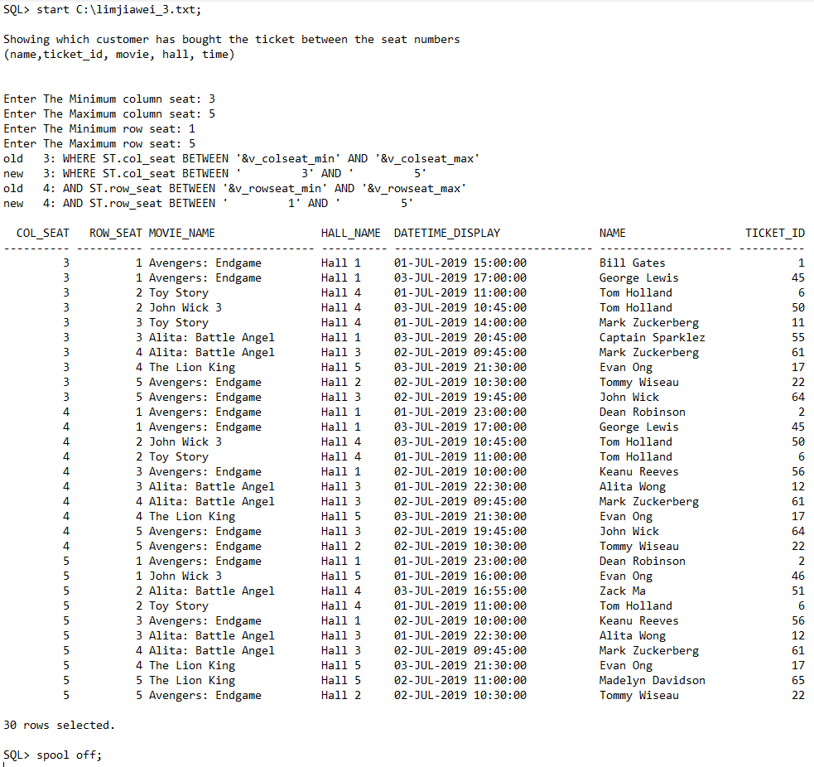

**Team member:** Tan Jin Eng

**1st Query**

**QUERY**

column datetime_display format A30

cl scr

/* Tan Jin Eng Queries 1*/

PROMPT Input the movie, and show the schedule (movie, hall, time)

PROMPT

PROMPT

ACCEPT v_movie char FORMAT 'A25' PROMPT 'Enter Movie Name: '

SELECT M.Name AS movie_name, H.name AS hall_name, S.datetime_display

FROM movie M, hall H, schedule S

WHERE M.name = '&v_movie'

AND M.movie_id = S.movie_id

AND S.hall_id = H.hall_id

ORDER BY S.datetime_display;

clear column;

clear break;

**OUTPUT**

SQL> start C:\tanjineng_1.txt;

Input the movie, and show the schedule (movie, hall, time)

Enter Movie Name: Avengers: Endgame

old 3: WHERE M.name = '&v_movie'

new 3: WHERE M.name = 'Avengers: Endgame'

MOVIE_NAME HALL_NAME DATETIME_DISPLAY

------------------------------ ---------- ------------------------------

Avengers: Endgame Hall 1 01-JUL-2019 10:30:00

Avengers: Endgame Hall 1 01-JUL-2019 15:00:00

Avengers: Endgame Hall 1 01-JUL-2019 19:00:00

Avengers: Endgame Hall 1 01-JUL-2019 23:00:00

Avengers: Endgame Hall 1 02-JUL-2019 10:00:00

Avengers: Endgame Hall 2 02-JUL-2019 10:30:00

Avengers: Endgame Hall 1 02-JUL-2019 13:45:00

Avengers: Endgame Hall 2 02-JUL-2019 14:15:00

Avengers: Endgame Hall 3 02-JUL-2019 15:30:00

Avengers: Endgame Hall 3 02-JUL-2019 19:45:00

Avengers: Endgame Hall 3 02-JUL-2019 23:15:00

Avengers: Endgame Hall 3 03-JUL-2019 10:30:00

Avengers: Endgame Hall 3 03-JUL-2019 14:00:00

Avengers: Endgame Hall 1 03-JUL-2019 17:00:00

Avengers: Endgame Hall 5 03-JUL-2019 17:45:00

Avengers: Endgame Hall 4 03-JUL-2019 20:15:00

Avengers: Endgame Hall 2 03-JUL-2019 21:45:00

17 rows selected.

SQL> spool off;

**2nd Query**

**QUERY**

column datetime_display format A30;

column purchased_datetime format A30;

column movie_name format A25;

cl scr

/* Tan Jin Eng Queries 2*/

PROMPT Input the ticket id, to show all the ticket details such as movie name, customer name, hall name, total amount of ticket and the time of purchased.

PROMPT

PROMPT

ACCEPT v_ticket_id char FORMAT '999' PROMPT 'Enter Ticket ID: '

SELECT TD.ticket_id, C.name, M.name AS movie_name, H.name AS hall_name, S.datetime_display, TD.adult_quantity, TD.child_quantity, TD.purchased_datetime

FROM customer C, ticket_details TD, schedule S, movie M, hall H

WHERE TD.ticket_id = '&v_ticket_id'

AND C.user_id = TD.user_id

AND TD.schedule_id = S.schedule_id

AND S.movie_id = M.movie_id

AND S.hall_id = H.hall_id;

clear column;

clear break;

**OUTPUT**

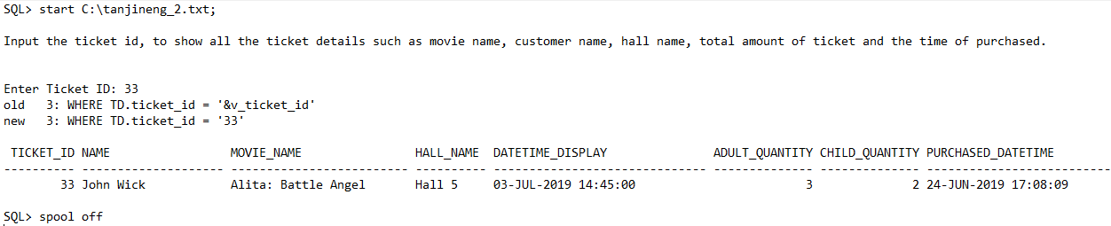

**3rd Query**

**QUERY**

column datetime_display format A30

column movie_name format A25

BREAK ON hall_name SKIP PAGE ON age_restricted

cl scr

/* Tan Jin Eng Queries 3*/

PROMPT Input the ticket id, and show the name, movie,hall name and schedule time, adult_quantity, child_quantity, purchased_datetime

PROMPT

PROMPT

ACCEPT v_age_restricted char FORMAT 'A10' PROMPT 'Enter Age-Restricted(PG-13, PG, G): '

SELECT M.age_restricted, M.name AS movie_name, H.name AS hall_name, S.datetime_display

FROM movie M, hall H, schedule S

WHERE M.age_restricted = UPPER('&v_age_restricted')

AND M.movie_id = S.movie_id

AND S.hall_id = H.hall_id

ORDER BY H.hall_id, S.datetime_display;

clear column;

clear break;

**OUTPUT**

SQL> start C:\tanjineng_3.txt;

Input the ticket id, and show the name, movie,hall name and schedule time, adult_quantity, child_quantity, purchased_datetime

Enter Age-Restricted(PG-13, PG, G): PG-13

old 3: WHERE M.age_restricted = UPPER('&v_age_restricted')

new 3: WHERE M.age_restricted = UPPER('PG-13')

AGE_RESTRICTED MOVIE_NAME HALL_NAME DATETIME_DISPLAY

---------------- ------------------------- ---------- ------------------------------

PG-13 John Wick 3 Hall 1 02-JUL-2019 22:55:00

Alita: Battle Angel 03-JUL-2019 11:15:00

Alita: Battle Angel 03-JUL-2019 20:45:00

John Wick 3 03-JUL-2019 23:30:00

AGE_RESTRICTED MOVIE_NAME HALL_NAME DATETIME_DISPLAY

---------------- ------------------------- ---------- ------------------------------

PG-13 Alita: Battle Angel Hall 2 02-JUL-2019 16:45:00

John Wick 3 02-JUL-2019 23:00:00

Alita: Battle Angel 03-JUL-2019 12:55:00

John Wick 3 03-JUL-2019 15:45:00

John Wick 3 03-JUL-2019 18:55:00

AGE_RESTRICTED MOVIE_NAME HALL_NAME DATETIME_DISPLAY

---------------- ------------------------- ---------- ------------------------------

PG-13 Alita: Battle Angel Hall 3 01-JUL-2019 10:00:00

Alita: Battle Angel 01-JUL-2019 13:15:00

Alita: Battle Angel 01-JUL-2019 16:30:00

Alita: Battle Angel 01-JUL-2019 19:30:00

Alita: Battle Angel 01-JUL-2019 22:30:00

Alita: Battle Angel 02-JUL-2019 09:45:00

AGE_RESTRICTED MOVIE_NAME HALL_NAME DATETIME_DISPLAY

---------------- ------------------------- ---------- ------------------------------

PG-13 John Wick 3 Hall 4 02-JUL-2019 11:30:00

John Wick 3 02-JUL-2019 14:15:00

Alita: Battle Angel 02-JUL-2019 17:00:00

Alita: Battle Angel 02-JUL-2019 19:55:00

John Wick 3 03-JUL-2019 10:45:00

Alita: Battle Angel 03-JUL-2019 16:55:00

AGE_RESTRICTED MOVIE_NAME HALL_NAME DATETIME_DISPLAY

---------------- ------------------------- ---------- ------------------------------

PG-13 John Wick 3 Hall 5 01-JUL-2019 09:30:00

John Wick 3 01-JUL-2019 12:30:00

John Wick 3 01-JUL-2019 16:00:00

John Wick 3 01-JUL-2019 20:00:00

John Wick 3 01-JUL-2019 22:55:00

John Wick 3 03-JUL-2019 12:00:00

Alita: Battle Angel 03-JUL-2019 14:45:00

John Wick 3 03-JUL-2019 23:55:00

29 rows selected.

SQL> spool off;

**Team member:** Chan Sin Yow

**1st Query**

**QUERY**

column genre format A15;

column datetime_display format A25;

column movie_name format A25;

BREAK ON genre ON hall_name SKIP 1;

cl scr

/* Chan Sin Yow Queries 1*/

PROMPT Input the genre, to show which movie, hall and the time_displayed order by hall name and datetime_display

PROMPT

PROMPT

ACCEPT v_genre char FORMAT 'A20' PROMPT 'Enter Genre of Movie(Action/Sci-Fi/Fantasy): '

SELECT M.genre, M.name AS movie_name, H.name AS hall_name, S.datetime_display

FROM movie M, hall H, schedule S

WHERE M.movie_id = S.movie_id

AND S.hall_id = H.hall_id

AND M.genre = '&v_genre'

ORDER BY H.name, M.name, S.datetime_display;

clear column;

clear break;

**OUTPUT**

SQL> start C:\chansinyow_1.txt;

Input the genre, to show which movie, hall and the time_displayed order by hall name and datetime_display

Enter Genre of Movie(Action/Sci-Fi/Fantasy): Fantasy

old 5: AND M.genre = '&v_genre'

new 5: AND M.genre = 'Fantasy'

GENRE MOVIE_NAME HALL_NAME DATETIME_DISPLAY

--------------- ------------------------- ---------- -------------------------

Fantasy The Lion King Hall 1 02-JUL-2019 17:30:00

The Lion King 02-JUL-2019 20:15:00

Toy Story 03-JUL-2019 14:00:00

The Lion King Hall 2 01-JUL-2019 11:30:00

The Lion King 01-JUL-2019 14:30:00

The Lion King 01-JUL-2019 18:00:00

The Lion King 01-JUL-2019 20:45:00

The Lion King 03-JUL-2019 10:15:00

Toy Story 02-JUL-2019 19:30:00

The Lion King Hall 3 03-JUL-2019 17:45:00

Toy Story 02-JUL-2019 12:30:00

Toy Story 03-JUL-2019 20:45:00

The Lion King Hall 4 02-JUL-2019 22:45:00

Toy Story 01-JUL-2019 11:00:00

Toy Story 01-JUL-2019 14:00:00

Toy Story 01-JUL-2019 17:30:00

Toy Story 01-JUL-2019 21:00:00

Toy Story 03-JUL-2019 14:00:00

The Lion King Hall 5 02-JUL-2019 11:00:00

The Lion King 02-JUL-2019 14:00:00

The Lion King 03-JUL-2019 09:45:00

The Lion King 03-JUL-2019 21:30:00

Toy Story 02-JUL-2019 16:45:00

Toy Story 02-JUL-2019 19:30:00

Toy Story 02-JUL-2019 22:15:00

25 rows selected.

SQL> spool off;

**2nd Query**

**QUERY**

column purchased_datetime format A25

column total_amount format 99999.99

BREAK ON REPORT

COMPUTE SUM LABEL TOTAL OF adult_quantity child_quantity total_amount ON REPORT

cl scr

/* Chan Sin Yow Queries 2*/

PROMPT Input The purchasing between time, To show (customer name, ticket_id, movie, hall, adult_quantity, child_quantity, total_amount)

PROMPT

PROMPT

ACCEPT v_betweentime_min char FORMAT 'A25' PROMPT 'Enter Time Between Minimum(DD-MON-YYYY HH24:MM:SS): '

ACCEPT v_betweentime_max char FORMAT 'A25' PROMPT 'Enter Time Between Maximum(DD-MON-YYYY HH24:MM:SS): '

SELECT TD.purchased_datetime, C.name, TD.ticket_id, M.name, H.name, TD.adult_quantity, TD.child_quantity, TD.total_amount

FROM customer C, ticket_details TD, movie M, hall H, schedule S

WHERE TD.purchased_datetime BETWEEN '&v_betweentime_min' AND '&v_betweentime_max'

AND TD.user_id = C.user_id

AND TD.schedule_id = S.schedule_id

AND S.movie_id = M.movie_id

AND S.hall_id = H.hall_id

ORDER BY purchased_datetime;

clear column;

clear break;

clear compute;

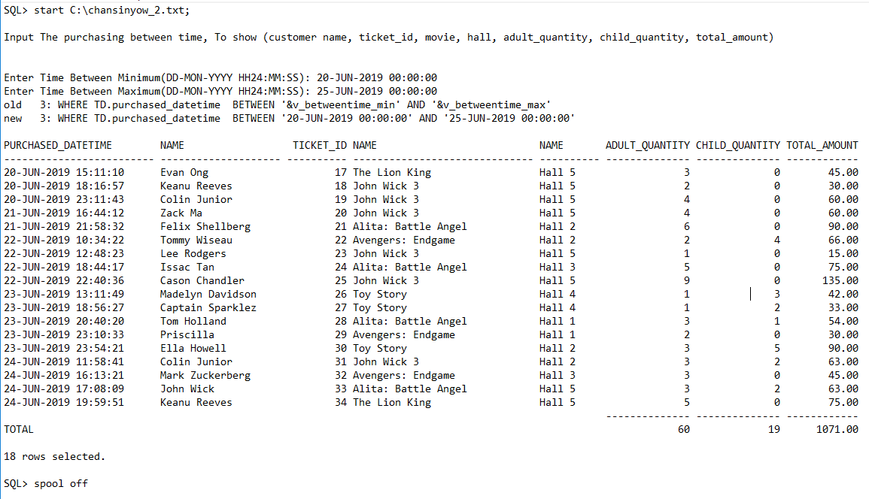**OUTPUT**

**3rd Query**

**QUERY**

column datetime_display format A25

BREAK ON movie_name;

COMPUTE SUM LABEL TOTAL OF total_ticket ON movie_name

cl scr

/* Chan Sin Yow Queries 3*/

PROMPT Show the total quantity of ticket, hall name and time on the particular movie

PROMPT

PROMPT

ACCEPT v_movie char FORMAT 'A25' PROMPT 'Enter Movie Name: '

SELECT M.name AS movie_name, S.datetime_display, H.name, TD.adult_quantity + TD.child_quantity AS total_ticket

FROM movie M, hall H, schedule S, ticket_details TD

WHERE M.name = '&v_movie'

AND TD.schedule_id = S.schedule_id

AND S.movie_id = M.movie_id

AND S.hall_id = H.hall_id

ORDER BY M.name, S.datetime_display;

clear column;

clear break;

clear compute;

**OUTPUT**

SQL> start C:\chansinyow_3.txt;

Show the total quantity of ticket, hall name and time on the particular movie

Enter Movie Name: Alita: Battle Angel

old 3: WHERE M.name = '&v_movie'

new 3: WHERE M.name = 'Alita: Battle Angel'

MOVIE_NAME DATETIME_DISPLAY NAME TOTAL_TICKET

------------------------------ ------------------------- ---------- ------------

Alita: Battle Angel 01-JUL-2019 10:00:00 Hall 3 1

01-JUL-2019 13:15:00 Hall 3 3

01-JUL-2019 13:15:00 Hall 3 5

01-JUL-2019 16:30:00 Hall 3 5

01-JUL-2019 19:30:00 Hall 3 4

01-JUL-2019 22:30:00 Hall 3 3

02-JUL-2019 09:45:00 Hall 3 4

02-JUL-2019 16:45:00 Hall 2 6

02-JUL-2019 16:45:00 Hall 2 1

02-JUL-2019 17:00:00 Hall 4 5

03-JUL-2019 11:15:00 Hall 1 4

03-JUL-2019 12:55:00 Hall 2 1

03-JUL-2019 14:45:00 Hall 5 4

03-JUL-2019 14:45:00 Hall 5 5

03-JUL-2019 16:55:00 Hall 4 1

03-JUL-2019 20:45:00 Hall 1 2

****************************** ------------

TOTAL 54

16 rows selected.

SQL> spool off;

**Team member:** Wong Chin Yuan

**1st Query**

**QUERY**

column movie_name format A25

cl scr

/* Wong Chin Yuan Queries 1*/

PROMPT Input movie, to show the total sum of adult_quantity and child_quantity

PROMPT

PROMPT

ACCEPT v_movie char FORMAT 'A25' PROMPT 'Enter Movie Name: '

SELECT M.name AS movie_name, SUM(TD.adult_quantity) + SUM(TD.child_quantity) AS ticket_sold

FROM movie M, ticket_details TD, schedule S

WHERE M.name = '&v_movie'

AND TD.schedule_id = S.schedule_id

AND S.movie_id = M.movie_id

GROUP BY M.name;

clear column;

clear break;

**OUTPUT**

SQL> start C:\wongchinyuan_1.txt;

Input movie, to show the total sum of adult_quantity and child_quantity

Enter Movie Name: The Lion King

old 3: WHERE M.name = '&v_movie'

new 3: WHERE M.name = 'The Lion King'

MOVIE_NAME TICKET_SOLD

------------------------- -----------

The Lion King 47

SQL> spool off;

**2nd Query**

**QUERY**

BREAK ON genre

COMPUTE SUM LABEL TOTAL OF ticket_sold ON genre

cl scr

/* Wong Chin Yuan Queries 2*/

PROMPT Input the genre to show the quantity of ticket have sold according to the movie name

PROMPT

PROMPT

ACCEPT v_genre char FORMAT 'A15' PROMPT 'Enter Genre(Action/Sci-Fi/Fantasy): '

SELECT M.genre, M.name AS movie_name, SUM(TD.adult_quantity) + SUM(TD.child_quantity) AS ticket_sold

FROM movie M, schedule S, ticket_details TD

WHERE M.movie_id = S.movie_id

AND S.schedule_id = TD.schedule_id

AND M.genre = '&v_genre'

GROUP BY M.genre, M.name

ORDER BY M.genre;

clear column;

clear break;

clear compute;

**OUTPUT**

SQL> start C:\wongchinyuan_2.txt;

Input the genre to show the quantity of ticket have sold according to the movie name

Enter Genre(Action/Sci-Fi/Fantasy): Fantasy

old 5: AND M.genre = '&v_genre'

new 5: AND M.genre = 'Fantasy'

GENRE MOVIE_NAME TICKET_SOLD

-------------------- ------------------------------ -----------

Fantasy The Lion King 47

Toy Story 39

******************** -----------

TOTAL 86

SQL> spool off

**3rd Query**

**QUERY**

BREAK ON REPORT

COMPUTE SUM LABEL TOTAL -

AVG LABEL AVERAGE -

OF morethan_amount ON REPORT

cl scr

/* Wong Chin Yuan Queries 3*/

PROMPT Input the minimum amount of payment that each customer had paid (total_amount)

PROMPT

PROMPT

ACCEPT v_minimum char FORMAT '99' PROMPT 'Enter Minimum Amount of Payment: '

SELECT C.name AS customer_name, SUM(TD.total_amount) as morethan_amount

FROM ticket_details TD, customer C

WHERE C.user_id = TD.user_id

GROUP BY C.name

HAVING SUM(TD.total_amount) > &v_minimum;

clear column;

clear break;

clear compute;

**OUTPUT**

SQL> start C:\wongchinyuan_3.txt;

Input the minimum amount of payment that each customer had paid (total_amount)

Enter Minimum Amount of Payment: 200

old 5: HAVING SUM(TD.total_amount) > &v_minimum

new 5: HAVING SUM(TD.total_amount) > 200

CUSTOMER_NAME MORETHAN_AMOUNT

-------------------- ---------------

Felix Shellberg 207

Zack Ma 246

Cason Chandler 303

Colin Junior 258

John Wick 225

---------------

AVERAGE 247.8

TOTAL 1239

SQL> spool off;

**Personal Reflection**

**Team Member:** Ong Yi Pin

This semester we have learned few techniques about database development and applications. In the beginning I think this subject is very difficult but when to the end I already know how to create table and insert data to the database. This is quiet useful for future. A lot of thing in this subject we need to learn and practice, if didn’t practice actually do know how to move on. We need to draw ERD diagram and planning the attribute of primary key and foreign key.

**Team Member:** Lim Jia Wei

What did learn about is how to record some data inside the database. From tutorial, I learn it from practical 4 for how to create new records that directly from practical 1 and also to create queries from the assignment itself. The challenge that I have during the tutorial are creating table from the structure itself despite the fact that I know how to do it and can be confused by identifying the primary key and foreign key. What I need to do is to ask my current tutorial teacher to learn from my mistake and redo it. When I used SQLPlus is surprising useful to me is because it can create its database by inserting table format, insert data into the application. What I need to do is to type certain keyword to either alter the table to become tidier or change its value from the session itself.

**Team Member:** Tan Jin Eng

Doing this assignment let me feel that everything must practice first before carry out the result, because I meet a lot of problem doing this assignment like the table I already created but when I insert the data, the message prompt out said “table does not exit”. But after a few errors happen again I can completely insert the data to the table and the most annoying part is creating the record, this cost a lot of time to think and some record is duplicate with each other. Actually, this assignment I only help a little part or even not. The main character is my teammate they help me a lot by lend a hand to me and guide me to solve problem. From this assignment I learned database is a very useful tool to store data and I believe in the future that I will have more contact with it.

**Team Member:** Chan Sin Yow

In this assignment, I had learn how to design and join the table. I think the most difficult part is the task 6 inserting data, the work was very repetitive, which need to insert a lot of record that is time consuming. Beside, I think the most satisfied part is the query, which allow me to really think deeply in order to collect data by writing SQL statement, because it is like a puzzle for me to write a query, as I was interested in solving them.

**Team Member:** Wong Chin Yuan

Before developing the database, I thought that we can’t easily develop ideal database just using SQL language. In the half way of developing the database, especially creating the table for the database. I found that we can easily hit errors if we didn’t prepare ERD diagram and note down required DBDL, we are hardly to define which attribute has to be the primary key or foreign key in order to link tables to tables.